Project Solution 1

Green Skill Development Programme (GSDP)

Green Skill Development Programme (GSDP) is India’s one of the most important vocational training programmes. The main focus of this programme is mechanical/technical skills rather than ‘soft’ or ‘green’ skills. Skill India Mission is an important initiative of Prime Minister of India and under the Skill India Mission of Hon’ble Prime Minister, Ministry of Environment, Forest & Climate Change (MoEF&CC) creates a big network and by using expertise of ENVIS Hubs/RPs to train the youth of India in the field of environment and forest sector to develop their skill in this sector. It will help the youth of India to get employment and/or self-employment in environment and forest sector to protect the ecosystems and biodiversity. This whole process is called the Green Skill Development Programme (GSDP). The aim of this programme is to develop green skilled workers.

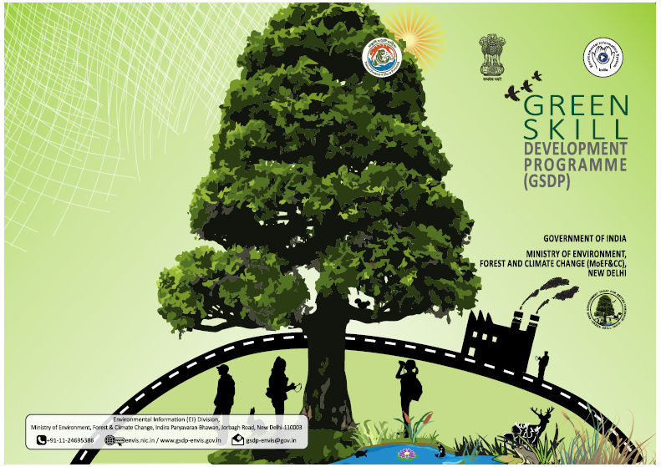

Background:
- India is a 1.25 billion people country, which comes second in the world .The demands of the skilled candidates are very high at various levels in the field of Environment and Forest sector in India.
- Skill development of youth is one of the key priorities of the Government of India. So, it can fill the gap of demand and supply of skilled candidate’s in various sectors such as environment, forest, climate change and other related sectors.

Opportunities:
- When the government realizes the importance of developing the green skills in these sectors then the Ministry of Environment, Forest & Climate Change (MoEF&CC) launched the Green Skill Development Programme (GSDP). This programme was launched in June, 2017 under the already running Environmental Information System (ENVIS) Scheme on a pilot basis.
- The aim of this programme was to skill youth in environment, forest and wildlife sectors. So they can get employed or self-employed in these sectors. In the beginning of this project, it was conducted at 10 locations, which is spread over 9 bio-geographic regions of the country.
- This pilot programme started with a Basic Course and an Advanced Course of 3 months’ duration each. The focus on this programme is to skill the youth as Biodiversity Conservationists and Para-taxonomists, respectively.
- This programme is run by the Botanical Survey of India (BSI) and Zoological Survey of India’s (ZSI) headquarters and their regional offices.
- When the candidates complete their Course(s) then they can be employed in the field of environment and forest sector such as wildlife sanctuaries, national parks, Wildlife Crime Control Bureau, manufacturing of green products, tourism, agriculture areas, etc.

Achievements:
- In the beginning of this project 94 Trainees successfully completed the basic course in Biodiversity Conservationists and 152 Trainees completed the Advanced Course as Para-taxonomists and get employed.
- When the pilot programme successfully completed then the Programme was expanded to all over India.
- Hon’ble Minister, EF&CC launched the full-fledged programme and started a Mobile app on GSDP on May 14, 2018.
- This app (gsdp-envis) has all basic information about the training programmes started under GSDP.

Current Status:
- Now under GSDP 44 Courses are offered at 87 locations in India. The duration of the courses is 80 hours to 550 hours.
- Some of the courses are as follows:
- Pollution Monitoring (air/water/soil)
- Emission Inventory;
- Sewage Waste Management
- Environmental Impact Assessment
- Forest Fire Management
- Water Budgeting & Auditing
- Wildlife Management
- Para Taxonomy
- Bamboo Management & Livelihood Generation etc.
- Now the training programmes are conducted by 87 institutions in the country.

Success Stories:
- There is huge demand for ‘green skilled candidates’ in the field of conservation and protection of environment sector such as forest and wildlife sanctuaries.
- Example:
Value Addition and Marketing of NTFPs (Plant Origin) – Certificate Course in “Lantana Furniture and Crafts” by Amrita University, Coimbatore:
Following figure shows the Lantana furniture and Crafts products produced by tribal community trained by Amrita University, Coimbatore to making Lantana furniture using Lantana. It helps in generating livelihood options for tribal community and also help in forest conservation.
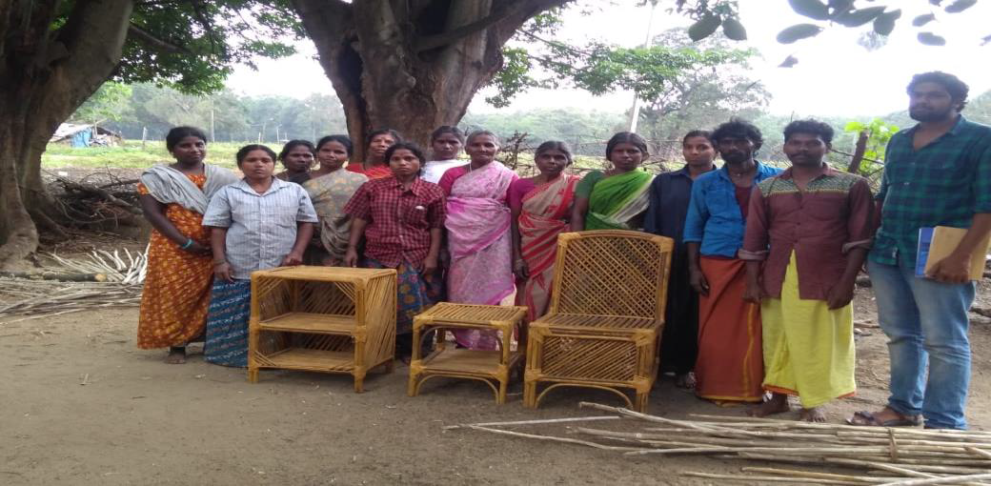Tribal Community under GSDP programme with lantana stems and the finished products.


Feedback:
- There are number of feedback is given by the trainers, experts, students and Centres, who is running and learning the courses regarding the course content, structure and timeline of the programme.
- The government accepted the suggestions and working for strengthening and improving the programme.

