Projects Solution 7
a.
Perform the following steps to create a new course named ‘Technology’:
- Open the RapidTyping application. The main window displays.
- Click the Lesson editor ( ) tab. The Lesson editor window displays (Figure 1).
- Click the Course menu and select the Create new course option.
A new course entry is shown in the navigation tree, as shown in Figure 1:
Figure 1: A New Course is added
- Type a name of the course, for instance Technology, as shown in Figure 2:
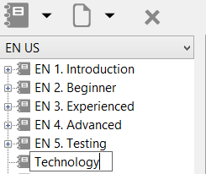
Figure 2: Entering a Name for the Course
- Press the Enter key to enter the new course name into the system. A new course will be created
and displayed in the list of courses.

b.

Perform the following steps to add a new lesson to a course:
- Open the RapidTyping application. The main window displays.
- Click the Lesson editor ( ) tab. The Lesson editor window displays.
- Select the course in the navigation tree in which you want to add a lesson. In this case, Technology is selected, as shown in Figure 3:
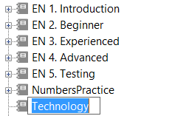
Figure 3: Selecting MyCourse
- Click the Lesson menu and select the Create new lesson option. A new lesson entry is shown in the navigation tree, as shown in Figure 4:
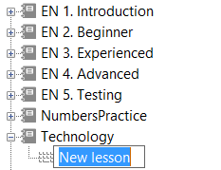
Figure 4: A New Lesson is added
- Type a name of the lesson, for instance, MICR Technology, as shown in Figure 5:
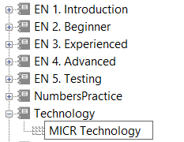
Figure 5: Entering a Name for the Lesson
- Press the Enter key to enter the new lesson name into the system. A new lesson will be created and displayed in the list of courses.
- Type the required content for typing practice to be done by a user, as shown in Figure 6:
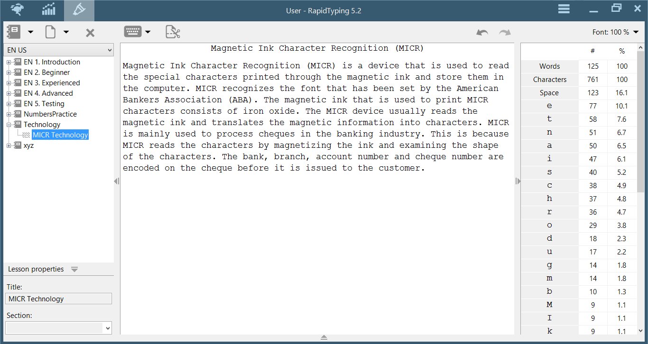
Figure 6: A New Lesson is created under the Required Course

c.
Test your typing skills by typing the same lesson and view your typing speed results as shown in Figure 7:
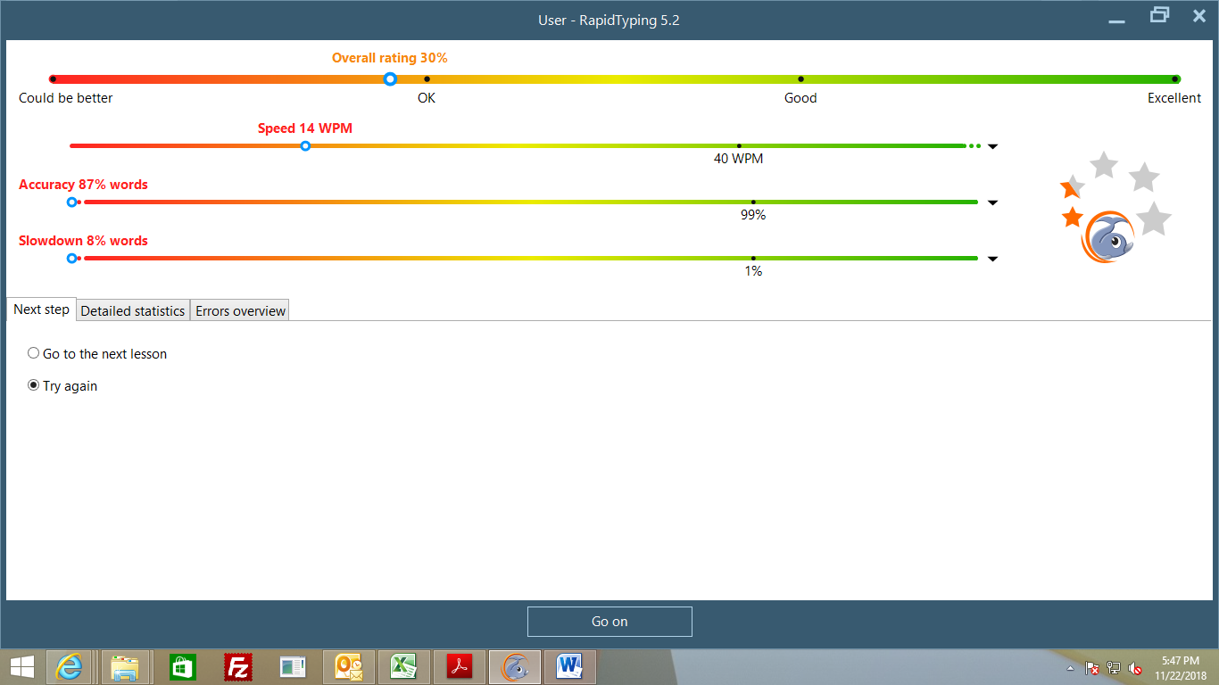
Figure 7: A user typing speed results

d.
Follow the previous steps to add a lesson in the course. In our case, we added QR Code lesson in the same course i.e. Technology as shown in the Figure 8:
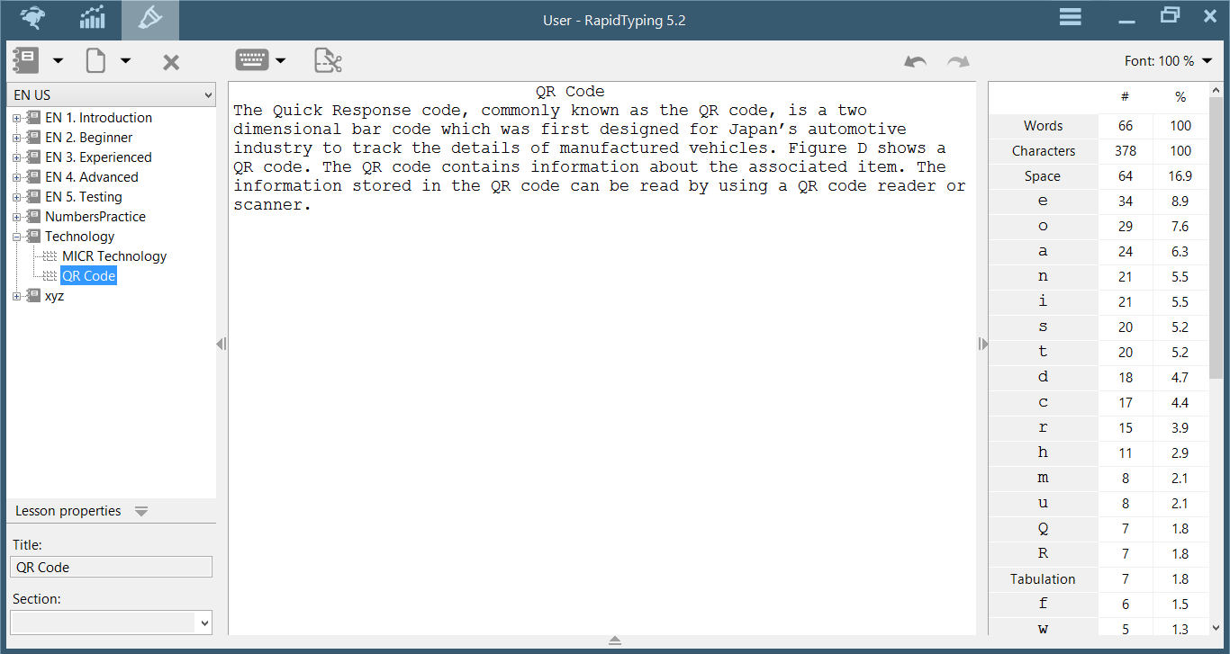
Figure 8: QR Code lesson is added

